BLACKWATER
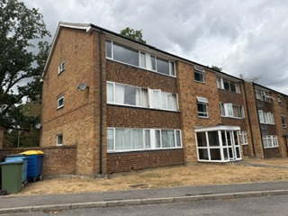
MUST BE VIEWED
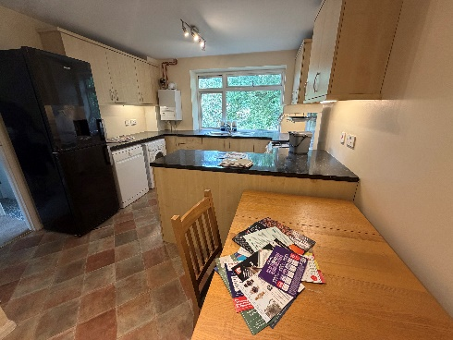
- DOUBLE GLAZED
- 2 DOUBLE BEDROOMS
- NO CHAIN
- KITCHEN/DINING ROOM
- PARKING
- NO CHAIN
17’ LOUNGE

£250,000

